***Bottom Menu***

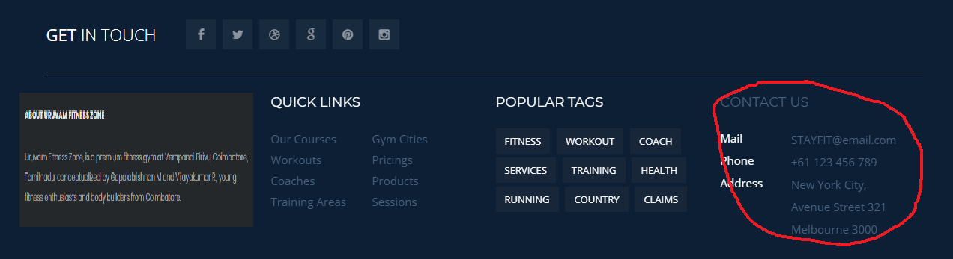

ABOUT URUVAM FITNESS ZONE

Uruvam Fitness Zone, is a premium fitness gym at Verapandi Pirivu, Coimbatore, Tamilnadu, conceptualized by Gopalakrishnan M and Vijayakumar R., young fitness enthusiasts and body builders from Coimbatore.

CONTACT US

Mail [uruvamfitness@gmail.com](mailto:uruvamfitness@gmail.com)

Phone +91 97871 75667

Address 2nd Floor, MK Towrs, Uruvam fitness zone, Veerapandi pirivu,

Coimbatore, Tamilnadu, India. 641047

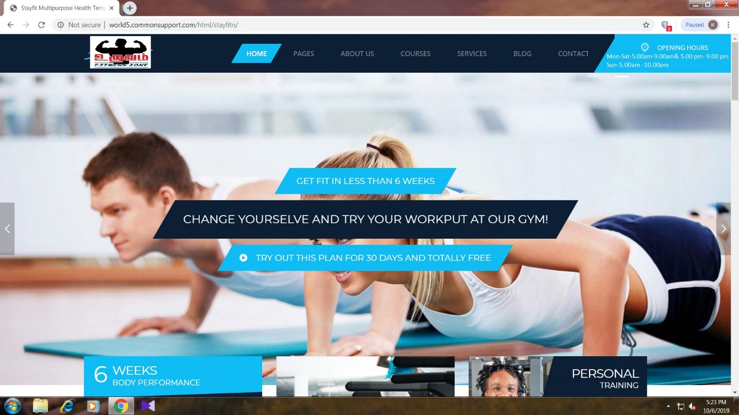

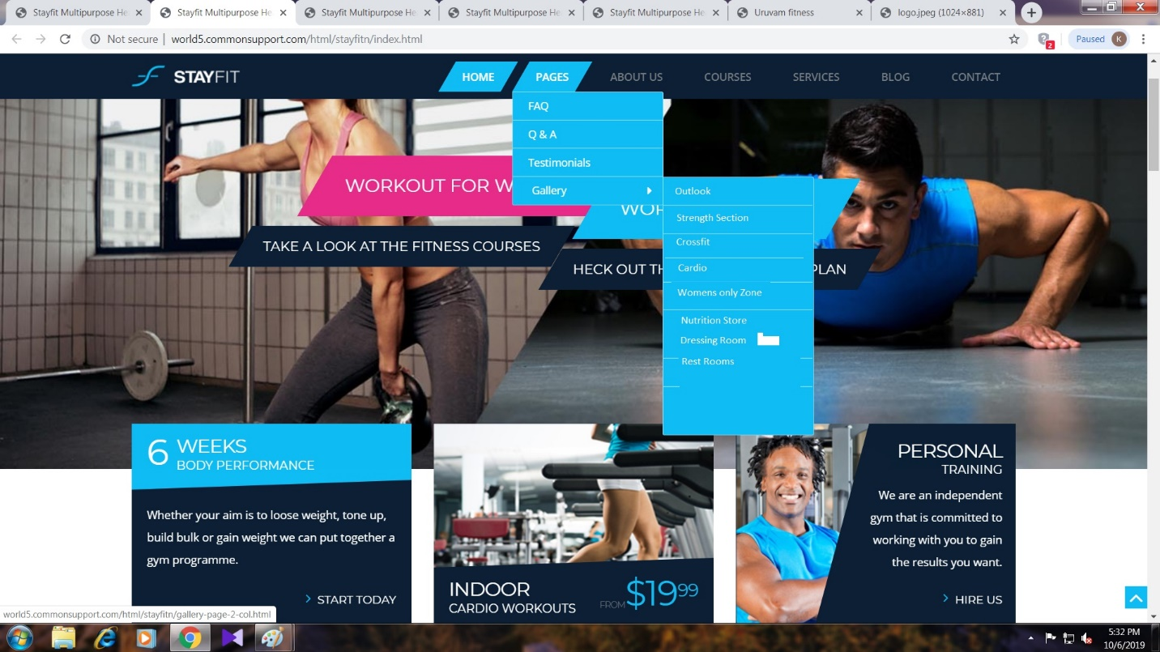

***FAQ***

[**Is personal training available at URUVAM Fitness Zone?**](https://www.goldstonefitness.ie/faq/#faq-19)

Yes! We have full time personal trainers available in house. You can find out more and book a PT session by contacting our admin. Each PT is freelance and sets his/her own rates, so contact them directly for a quote.

[**Can I get a Personalised Fitness Program?**](https://www.goldstonefitness.ie/faq/#faq-20)

Yes. Our Personal Trainers do this. Simply contact one of the PT's and they will arrange a time that suits you. Programs involve two meetings. The first is a consultation about your goals, etc. The second is a one on one on the gym floor, going through your printed program in detail and showing you how to do each exercise, proper technique & correct machine usage. This price list is available in gym for individual program.

[**What age do I need to be to join?**](https://www.goldstonefitness.ie/faq/#faq-23)

Due to insurance reasons, you must be 16 years old before becoming a member. Outside of that, you’re welcome at any age - because you’re never too old to keep fit and active.

[**Is there water available at the gym?**](https://www.goldstonefitness.ie/faq/#faq-24)

Yes. Water is available in gym. Purified RO water.

[**Is there separate rest rooms available in Uruvam?**](https://www.goldstonefitness.ie/faq/#faq-24)

Yes. Rest rooms for gents and ladies separately available.

[**Is there separate dressing rooms available in Uruvam?**](https://www.goldstonefitness.ie/faq/#faq-24)

Yes. Dressing rooms for gents and ladies separately available.

[**Is there free wi-fi at uruvam?**](https://www.goldstonefitness.ie/faq/#faq-13)

There is currently no members wi-fi at the club.

[**I have a health issue, can i still exercise?**](https://www.goldstonefitness.ie/faq/#faq-12)

Yes, but it will depend on your condition and medical clearance may need to be provided by your doctor. We have specialised staff that can help you and members are regularly referred to us by their doctor. If you have a specific medical issue, please email the details in confidence to join@goldstonefitness.ie and attach a copy of your doctor/physio clearance letter to this email.

[**What is your heaviest dumbbell?**](https://www.goldstonefitness.ie/faq/#faq-11)

Dumbbells go from 1 kg to 45 kg...and we have LOTS of them!

**Will trainer help me my first time?**

Yes! Yes! Yes! Everyone is entitled to help. You should never feel like you are bothering us or imposing. Don’t be shy, please just walk up to the front counter or any training coach. Although we are unable to stay with you through your entire workout, we can help with most questions, introduction to equipment, and basic nutrition advice.

To get the absolute most out of your time, we suggest scheduling an appointment with the club head trainer. **Do I wear when I come to the gym?**

Proper workout attire is always recommended. Shirts and athletic shoes are mandatory. We recommend you wear comfortable sneakers and clothing suitable for exercise. Prohibited are open-toed shoes, flip-flops, and work-boots.

**MENU: COURSES**

**CrossFit Courses**

As an Uruvam fitness zone member, you can also access our exclusive CrossFit zone for free and have priority for booking any of the pre-book activities.

**Personal Training**

As an Uruvam fitness zone member, you can also utilize our personal training by well-experienced personal trainers for your quick results.

**Outdoor Activities**

As an Uruvam fitness zone member, you can also access our monthly trucking and outdoor activities for a change.

**Women’s Zone**

As an Uruvam fitness zone women’s member, you can access our women’s only zone for your privacy environment.

**Zumba**

As an Uruvam fitness zone member, you can also access our Zumba classes by expert trainers at nominal cost.

**Body Strength Workout**

As an Uruvam fitness zone member, you can also access our advanced body strength programme at a nominal cost.

**Cardio Theatre workout**

As an Uruvam fitness zone member, you can allow to access our exclusive cardio theatre for better weight loss workouts.

**Home Workout Courses**

As an Uruvam fitness zone member, you can also access our online home workout courses at nominal tariff.

**Menu: Store**

Sub Menu: Nutrition Zone

Sub Menu: Gym Apparels

Menu: OUR PRICING

### STUDENT BASIC PLAN

**600Rs/-**/month

Fitness workout plan

Food Chart

Flexible timing

CrossFit Access

Unlimited gym entrance

[CONTACT NOW](http://world5.commonsupport.com/html/stayfitn/pricing.html)

### STUDENT ADVANCED PLAN

**3200Rs/-**/ 6 months

Food Chart

Flexible timing

CrossFit Access

5 % Cash Back

* [CONTACT NOW](http://world5.commonsupport.com/html/stayfitn/pricing.html)

### STUDENT professional PLAN

**6000Rs/-**/12 months

Food Chart

Flexible timing

CrossFit Access

10 % Cash Back

[CONTACT NOW](http://world5.commonsupport.com/html/stayfitn/pricing.html)

### ADULT BASIC PLAN

**700Rs/-**/month

Fitness workout plan

Food Chart

Flexible timing

CrossFit Access

Unlimited gym entrance

[CONTACT NOW](http://world5.commonsupport.com/html/stayfitn/pricing.html)

### ADULT ADVANCED PLAN

**4000Rs/-**/6 months

Fitness workout plan

Food Chart

Flexible timing

CrossFit Access

5 % Cash Back

[CONTACT NOW](http://world5.commonsupport.com/html/stayfitn/pricing.html)

### ADULT professional PLAN

**7500Rs/-**/12 months

Fitness workout plan

Food Chart

Flexible timing

CrossFit Access

10 % Cash Back

[CONTACT NOW](http://world5.commonsupport.com/html/stayfitn/pricing.html)

### COUPLES BASIC PLAN

**1300Rs/-**/month

Fitness workout plan

Food Chart

Flexible timing

CrossFit Access

Unlimited gym entrance

[CONTACT NOW](http://world5.commonsupport.com/html/stayfitn/pricing.html)

### COUPLES ADVANCED PLAN

**7700Rs/-**/6 months

Fitness workout plan

Food Chart

Flexible timing

CrossFit Access

5 % Cash Back

[CONTACT NOW](http://world5.commonsupport.com/html/stayfitn/pricing.html)

### COUPLES professional PLAN

**14500Rs/-**/12 months

Fitness workout plan

Food Chart

Flexible timing

CrossFit Access

10 % Cash Back

[CONTACT NOW](http://world5.commonsupport.com/html/stayfitn/pricing.html)

### PERSONAL BASIC PLAN

**3000Rs/-**/month

20 Efficient classes

100 Percent Results

Food and Workout Chart

Workout Remainder

CrossFit Classes

[CONTACT NOW](http://world5.commonsupport.com/html/stayfitn/pricing.html)

### PERSONAL ADVANCED PLAN

**6000Rs/-**/3 months

70 burning classes

Basic Plan

Circuit Workouts

Body Fitness Checkup

Demo classes for Zumba

[CONTACT NOW](http://world5.commonsupport.com/html/stayfitn/pricing.html)

### PERSONAL professional PLAN

**14000Rs/-**/6 months

150 Wonder Classes

Advanced Plan

Zumba Classes

Medical Suggestions

10 percent cash back

[CONTACT NOW](http://world5.commonsupport.com/html/stayfitn/pricing.html)

ABOUT US

### OUR TRAINERS

## **MEET OUR TRAINER HEADS & PERSONAL TRAINERS**

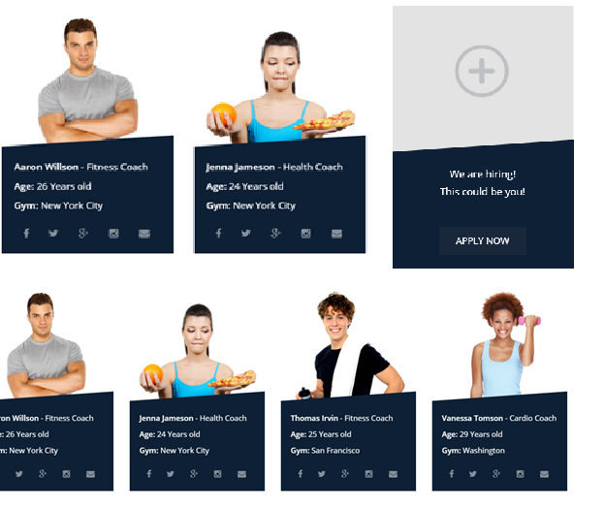

Rogeshwaran – Trainer head & Personal Trainer

Age: 26 Years old

Natural Bodybilding Expert

Vijayakumar – Trainer head & Personal Trainer

Age: 30 Years old

Fitness Expert

Arunpandian – Personal Trainer

Age: 25 Years old

Fitness Expert

Balasurya – Personal Trainer

Age: 20 Years old

Fitness Expert

Hassif Hussian – Personal Trainer

Age: 24 Years old

Fitness Expert

